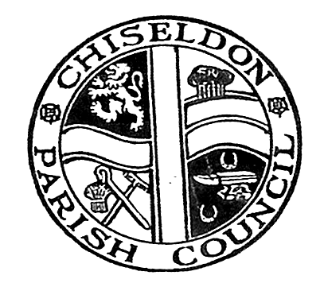

Chiseldon Parish Council

The Old Chapel, Butts Road, Chiseldon, Wilts SN4 0NW
 01793 740744 (Emergency 07712 812877)
email: clerk@chiseldonparishcouncil.com
website: www.chiseldonparishcouncil.com

CHISELDON PARISH COUNCIL
RESPONSE TO COMMUNITY GOVERNANCE REVIEW (CGR) STAGE 3

Chiseldon Parish Council (CPC) would like to restate for the CGR stage 3 , its support to retain the existing Parish boundaries of Chiseldon.

Specifically CPC would like to confirm its support to retain Badbury Park within the boundary of Chiseldon Parish. The CPC unanimously voted in favour of this motion at the Parish Council on the 11th July 2016.

As noted in our submission to CGR stage 2

- Our current boundaries represent a growing rich and diverse mix of residents.
- Chiseldon Parish residents have actively created an inclusive, caring and supportive community. An excellent example of this has recently been demonstrated by the recent Chiseldon Charity Fete which was driven, supported and managed by residents drawn from all areas within the Parish.
- The Parish Council is committed to retaining its historical boundaries.
- A new Parish Councillor was co-opted on the 11th July to represent Badbury Park Community Association (BPCA) and to strengthen the CPC commitment to supporting the Badbury Park community. It is expected that another Parish Councillor from Badbury Park will be co-opted again shortly.

Over the last month CPC has been working closely with the BPCA to understand the views and preferences of the Badbury Park Community with regard to remaining within Chiseldon Parish or moving to the proposed new “ South Swindon Parish”

To facilitate this understanding , CPC with the support of the BPCA, carried out a poll amongst Badbury Park residents.

A leaflet was distributed to over 300 houses on Badbury park and Coate Estate between 23-25th September. The leaflet asked residents to give their opinion on whether they wished to remain within the parish of Chiseldon or move into a newly formed ‘South Swindon Parish ‘. Responses were made via an online form and by telephone.

Results
There were 47 responses of which 8 were invalid
Chiseldon parish 30 (77%)
South Swindon Parish 9 (23%)

Engagement in this survey was low, possibly because of the previous work done by the former chair of the BPCA in polling and re-polling residents and suspected confusion as to whether Badbury Park could become unparished or a parish in its own right.

These options , however, were discounted as in the Stage 2 of CGR it was felt that while Badbury Park was still under construction , the size of the popualtion would not offer ‘convenient and effective governance’, similarly such a small parish would not benefit from economies of scale in contract negotion leading to poor value.

In closing , the CPC will clearly support whatever direction the Badbury Park community chooses to take.

The CPC , however, would like to impress upon the CGR that it is the residents choice that matters here and not a convenient boundary alteration that satisfies SBC future Parishing plans.

Please find attached a letter sent on behalf of Cllr David West and Badbury Park residents. Cllr West was recently co-opted onto CPC as a resident of Badbury Park. We would like this letter submitted as part of the stage 3 review.

Yours sincerely

Mrs Clair Wilkinson

Parish Clerk

CC Cllr Caroline Brady, Chair of Chiseldon Parish Council

